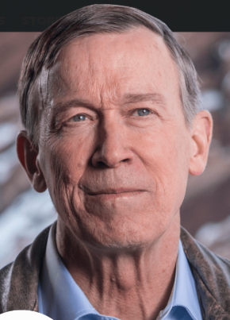
Name: John Hickenlooper
https://www.youtube.com/watch?v=Sr8UxkQZDzM
3:47
https://www.youtube.com/watch?v=QwIk0hUmzk8
2:26 preferred
State: Born: Pennsylvania
Current resident: Colorado
Current Position: Governor of Colorado
- Committees

- Education:
  - Wesleyan University BA in English, MA in geology
- Experience:
  - Geologist
  - Cofounded Wynkoop Brewing Company
  - 43 mayor of Denver
- Position on Issues:

Crime

"It is a legitimate question whether we as a state should be taking lives."^{[28]} In Hickenlooper’s 2016 memoir, he came out against the death penalty. He explained that his views on the death penalty changed after becoming more familiarized with the research showing bias against minorities and people with mental illnesses.

Opposes the death penalty.

Drug costs

Economy

Education

Election issues

Environment

Hickenlooper’s administration created the first methane-capture regulations for oil and gas companies in the entire country. The rules prevented 95% of volatile organic compounds and methane from leaking from hydraulic fracturing wells.

After President Donald Trump announced that the United States would be leaving the Paris Climate Accord, Hickenlooper joined more than a dozen other states in sticking with the greenhouse gas emission reduction goals

Supports hydraulic fracking

Foreign Policy

Guns

Hickenlooper signed bills HB1224, HB1228 and HB1229. HB1224 created a limit of 15 rounds in magazines that could be bought, sold or transferred within the state. HB1229 requires background checks for any firearm transfer within the state, and HB1228 taxes firearm transfers to recover costs of the background checks from HB1229.

supported a Red Flag or Extreme Risk Protection Order bill in the legislature that would have allowed judges to temporally restrict firearm access to those who were deemed a significant risk to themselves or others

Healthcare

In 2011, Hickenlooper signed SB11-200 which had passed through the Republican-held state house to create Colorado’s health care exchange. In 2013, Hickenlooper signed SB13-200 to expand Medicaid as a part of the Affordable Care Act. After these changes, Colorado’s insured rate rose to 93.5 percent.

Opposes Medicare for all, siting the many people who are satisfied with their current insurance.

Housing

Immigration

Monopolies and government intervention

Opioid epidemic response

Social Issues and Civil Rights

announced a "10 Year Plan to End Homelessness" at the U.S. Conference of Mayors

Hickenlooper has indicated that his views have evolved, stating in May 2016 that Colorado's approach to cannabis legalization is "beginning to look like it might work"

Working class

signed House Bill 1241, which funds the Rural Economic Development Initiative (REDI)

launched a program called Skillful, with the help of LinkedIn and the Markle Foundation. The program uses online tools and on-the-ground advisors to help businesses create job descriptions to tap into a wider job pool and help job seekers fill high-need jobs and connect them with job training

