Name: Joseph Biden
https://www.realclearpolitics.com/video/2019/04/25/biden_launches_2020_campaign_america_is_at_stake.html
State: Born: Pennsylvania
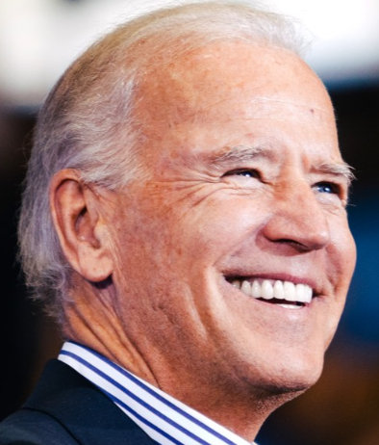
Current resident: Delaware
Current Position:
- Committees
  - Foreign Relations Committee (chair)
  - Senate Judiciary Committee (chair)
- Education:
  - University of Delaware
  - Syracuse University College of Law
- Experience:
  - Lawyer
  - New Castle County Council
  - US Senator
  - Vice President of US
- Position on Issues:

Crime

For Violent crime Control and Law Enforcement Act – focused on more prisons and on prevention

For Violence Against Women Act

Drug costs

Economy

Oversaw infrastructure spending as VP

Passed Tax Relief legislation

Unemployment insurance and Job Creation Act

supported deficit spending for fiscal stimulus in the American Recovery and Reinvestment Act of 2009

Education

Election issues

For campaign finance reform

Environment

climate change was an "existential threat to our future"

remain in Paris Agreement

Foreign Policy

Worked for ratification of the SALT II treaty

For economic sanctions against South Africa during apartheid

Opposed Gulf War in 1991

Advocated for intervention in Bosnia

Voted for Iraq War in 2002

Opposed troop surge in 2007

Guns

Against assault rifles

Healthcare

For pre-existing condition coverage without premium hike

Housing

Opposed roadways that would destroy housing areas

Immigration

For DACA protection

Monopolies and government intervention

Opioid epidemic response

Social Issues and Civil Rights

Opposed desegregation busing

Every patriotic American who is qualified to serve in our military should be able to serve. Full stop. (with reference to LGBTQ persons)

Recognize ‘same sex marriage’ rights

Working class

